DAY 4 (11-01-2018)

* select \* from c1 where name like '%n';

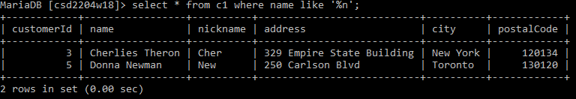

* select \* from c1 where customerId not between 4 and 7;

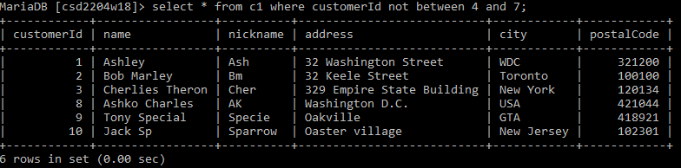

* select \* from c1 where nickname not in('Bm','AK','Sparrow');

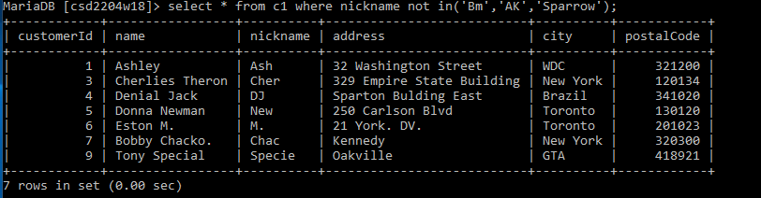

* select customerId,name,nickname from c1 where nickname not in('Bm','AK','Sparrow');

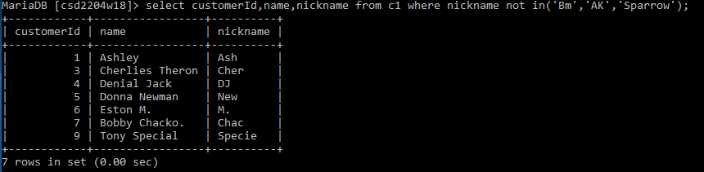

* select customerId,name,city from c1 where nickname not in('Bm','AK','Sparrow');

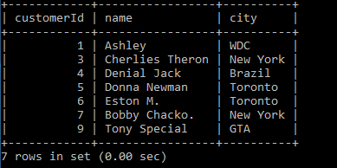

* select customerId,name AS "Fullname" from c1 where nickname not in('Bm','AK','Sparrow');

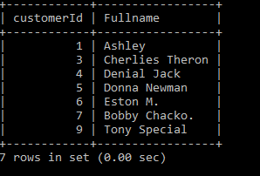

* select count(\*) from c1 where name like 'A%';

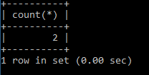

* select count(\*) as "Total number of customer whose name start with A" from c1 where name like 'A%';

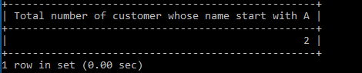

* select count(\*) as "Total Customer of Toronto" from c1 where city='Toronto';

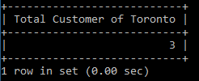

* select distinct(city) from c1;

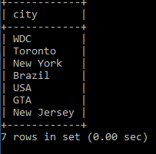

* select 'Toronto' as city, count(\*) from c1 where city='Toronto'
* -> union
* -> select 'USA' as city, count(\*) from c1 where city='USA'
* -> union
* -> select 'New York' as city, count(\*) from c1 where city='New York';

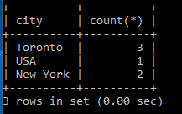

* select \* from c1 order by name asc ;

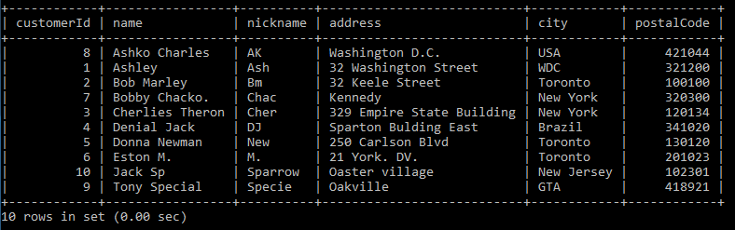

* select \* from c1 order by name desc;

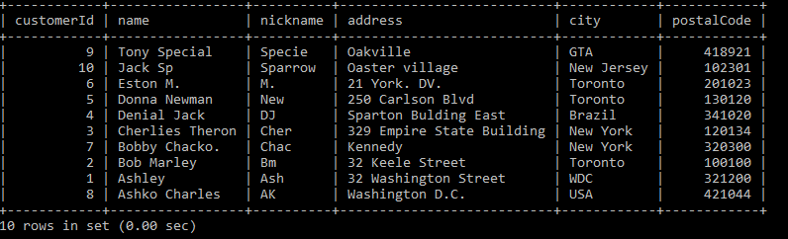

* select \* from c1 order by postalCode ;

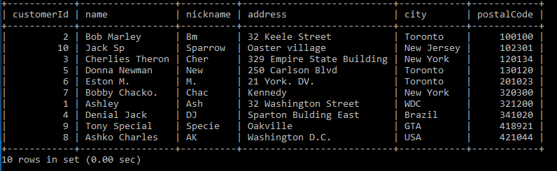

* select \* from c1 order by city asc;

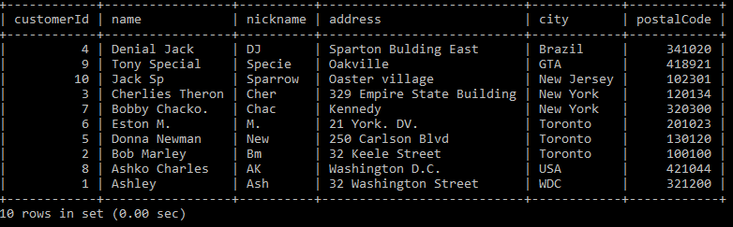

* select \* from c1 order by city,postalCode;

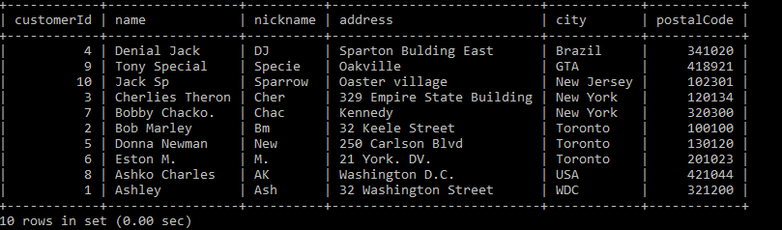

* select \* from c1 order by postalCode desc,city;

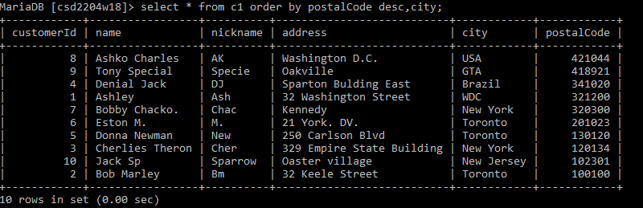

* select \* from c1 order by customerId desc,name asc, city desc;

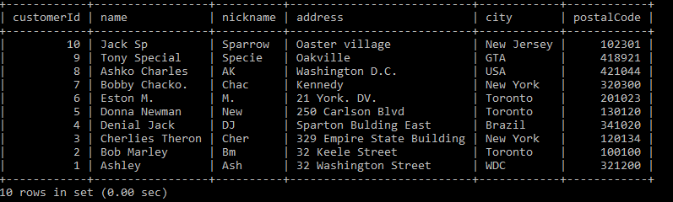

* select count(\*) as “Total”, city from c1 group by city;

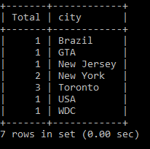

* select \* from c1 where name like'D%' group by city;

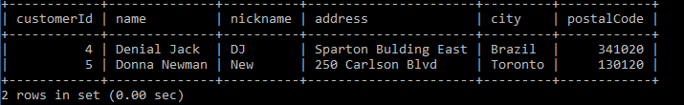

* select min(postalCode) from c1;

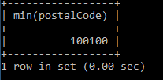

* select max(postalCode) from c1;

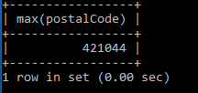

* select sum(postalCode) from c1;

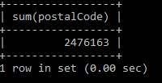

* select avg(postalCode) from c1;

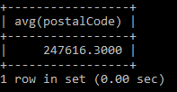

* select max(city),min(address) from c1;

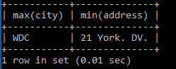

* select max(city) from c1;

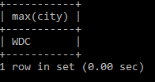

* select min(address) from c1;

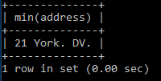

* select count(\*) as "Total number of person who live in Toronto" from c1 where city='Toronto';

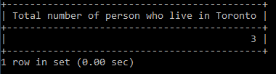

* select name, count(\*) as "Total number of person who live in Toronto" from c1 where city='Toronto' group by name;

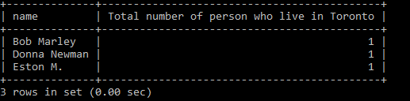

* select \* from c1 limit 5;

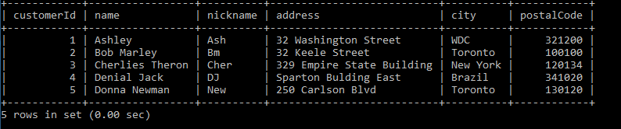

* select \* from c1 order by customerId desc limit 5;

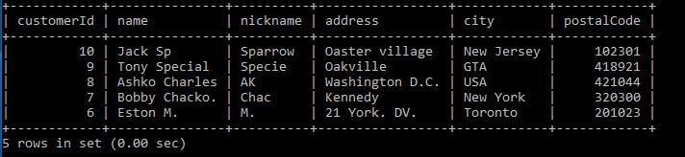

* select \* from(select \* from c1 order by customerId desc limit 3)t order by customerId asc;

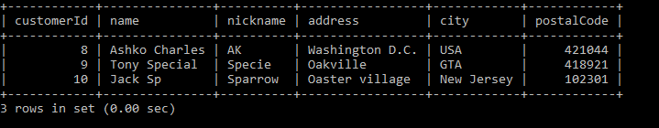

* select \* from c1 where nickname is null;

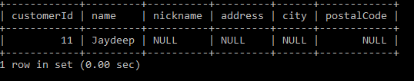

* select \* from c1 where nickname is not null;

